|  |
| --- |
| **# Linear Regression**  **# Height vector**  x <- c(153, 169, 140, 186, 128,         136, 178, 163, 152, 133)    **# Weight vector**  y <- c(64, 81, 58, 91, 47, 57,         75, 72, 62, 49)    **# Create a linear regression model**  model <- lm(y~x)    **# Print regression model**  print(model)    **# Find the weight of a person With height 182**  df <- data.frame(x = 182)  res <-  predict(model, df)  cat("\nPredicted value of a person                 with height = 182")  print(res)    **# Output to be present as PNG file**  png(file = "linearRegGFG.png")    **# Plot**  plot(x, y, main = "Height vs Weight Regression model")  abline(lm(y~x))    **# Save the file.**  dev.off() |

**Output:**

Call:

lm(formula = y ~ x)

Coefficients:

(Intercept) x

-39.7137 0.6847

Predicted value of a person with height = 182

1

84.9098

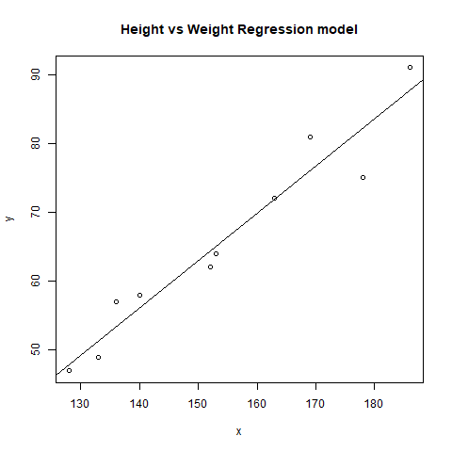

|  |
| --- |
| **# Multiple Linear Regression**  **# Using airquality dataset**  input <- airquality[1:50,c("Ozone", "Wind", "Temp")]    **# Create regression model**  model <- lm(Ozone~Wind + Temp,data = input)    **# Print the regression model**  cat("Regression model:\n")  print(model)    **# Output to be present as PNG file**  png(file = "multipleRegGFG.png")    **# Plot**  plot(model)    **# Save the file.**  dev.off() |

**Output:**

Regression model:

Call:

lm(formula = Ozone ~ Wind + Temp, data = input)

Coefficients:

(Intercept) Wind Temp

-58.239 -0.739 1.329

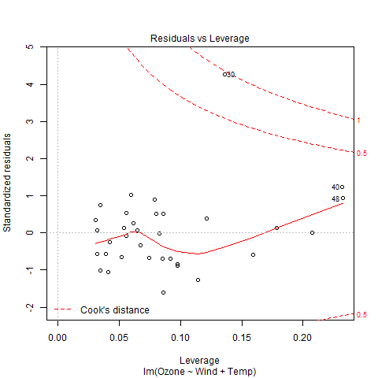

|  |
| --- |
| **#Logistic Regression**  **# Using mtcars dataset**  **# To create the logistic model**  model <- glm(formula = vs ~ wt,family = binomial,data = mtcars)    **# Creating a range of wt values**  x <- seq(min(mtcars$wt),max(mtcars$wt),0.01)    **# Predict using weight**  y <- predict(model, list(wt = x), type = "response")    **# Print model**  print(model)    **# Output to be present as PNG file**  png(file = "LogRegGFG.png")    **# Plot**  plot(mtcars$wt, mtcars$vs, pch = 16, xlab = "Weight", ylab = "VS")  lines(x, y)    **# Saving the file**  dev.off() |

**Output:**

Call: glm(formula = vs ~ wt, family = binomial, data = mtcars)

Coefficients:

(Intercept) wt

5.715 -1.911

Degrees of Freedom: 31 Total (i.e. Null); 30 Residual

Null Deviance: 43.86

Residual Deviance: 31.37 AIC: 35.37

